**Lab Report #3:** User Input and LCD

Brian Dawson

Joshua Annandsingh

Microcomputer Systems

9/27/19

The College of New Jersey

Department of Electrical and Computer Engineering (ECE)



**Introduction:**

In this lab, the students had to use PSoC Creator to create a project using the CY8CKIT-050 kit. The first part of the project was to write a message to the LCD on the board. The second component of the project was to update the LCD based on how users pressed different push buttons. The third component was to light up an LED overtime incrementally till peak brightness and then reverse the procedure and go back down to dark and then repeat. While this LED went from dark to bright, a different LED did the opposite.  **Procedure:**

Part 1

1. The students created a new PSoC Project.
2. The students added a digital input pin and mapped it to a switch on the PSoC board and gave it the pullup resistor.
3. The students then designed a C code to display the message:  
    *My First Microcontroller I/O Console Program  
    Microcontroller Programmer  
    Press a switch to continue*
4. The students put this code in an infinite loop that waited for the button to be pressed
5. Once the button was pressed the new display was set to:  
    *Program completion succeeded*
6. The students attached the LCD screen to the PSoC board
7. The students built and programmed this project to the board and confirmed its functionality

Part 2

1. The students created a new PSoC project
2. The students designed a C code to turned on two LEDs and gave a greeting message to the LCD
3. In this C code the students also designed it to ask the user to push either pushbutton and displayed the count of times pushed into the LCD while toggling the LED that was assigned to the pushbuttons. Count was recorded in Hex.
4. This program was adjusted for button debouncing
5. The students built and programmed this project to the board and confirmed its functionality

Part 3

1. The students created a new PSoC project
2. The students added a digital input pin and assigned it to a push button
3. The students added a digital output pin and assigned it to an output on the PSoC board
4. The students designed a C code that sets the value of the output to 1 when the button is pressed and set the value to 0 when it was not
5. The students built and programmed this project to the board and recorded the output through an oscilloscope

Part 4

1. The students created a new PSoC project
2. The students added a pulse width modulation to the Top Design
3. The students added two digital output pins and a clock to the Top Design
4. The students mapped the digital output pins to the LEDs on the board
5. The students connected the output pins to the output of the pwd
6. The students connected the clock to the clock input of the pwd
7. The students connected logical 0 to reset input of pwd
8. The students configured pwd so that cmp type 1 was less than and cmp type 2 was greater than
9. The students designed a C code to compare the pwd to a value counting to 255
10. The students built and programmed this project to the board and confirmed its functionality

**Results:**

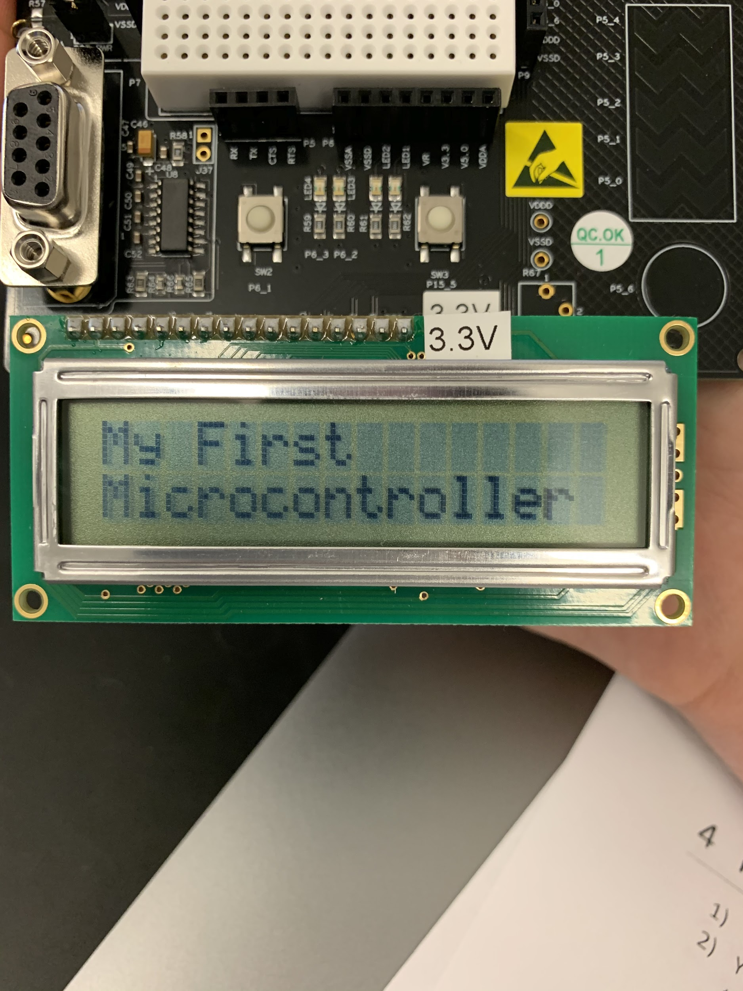

*Figure 1. First Line Displayed of Part 1*

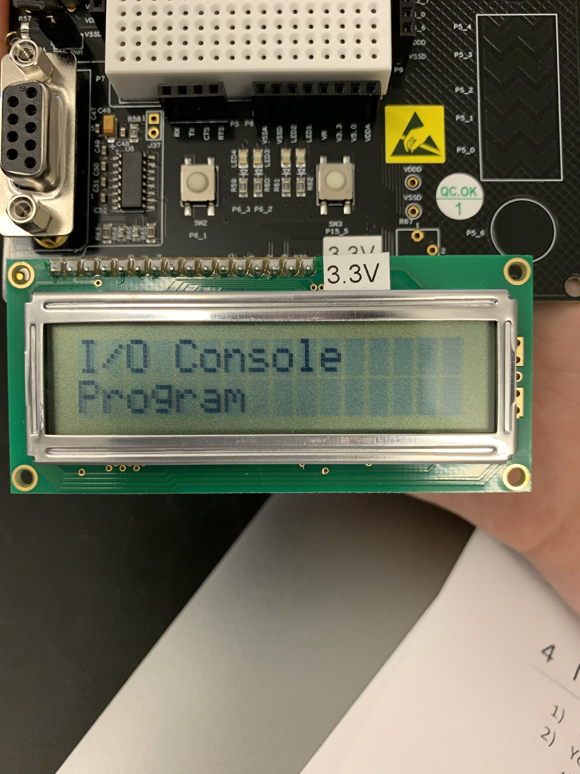

*Figure 2. Second Line Displayed of Part 1*

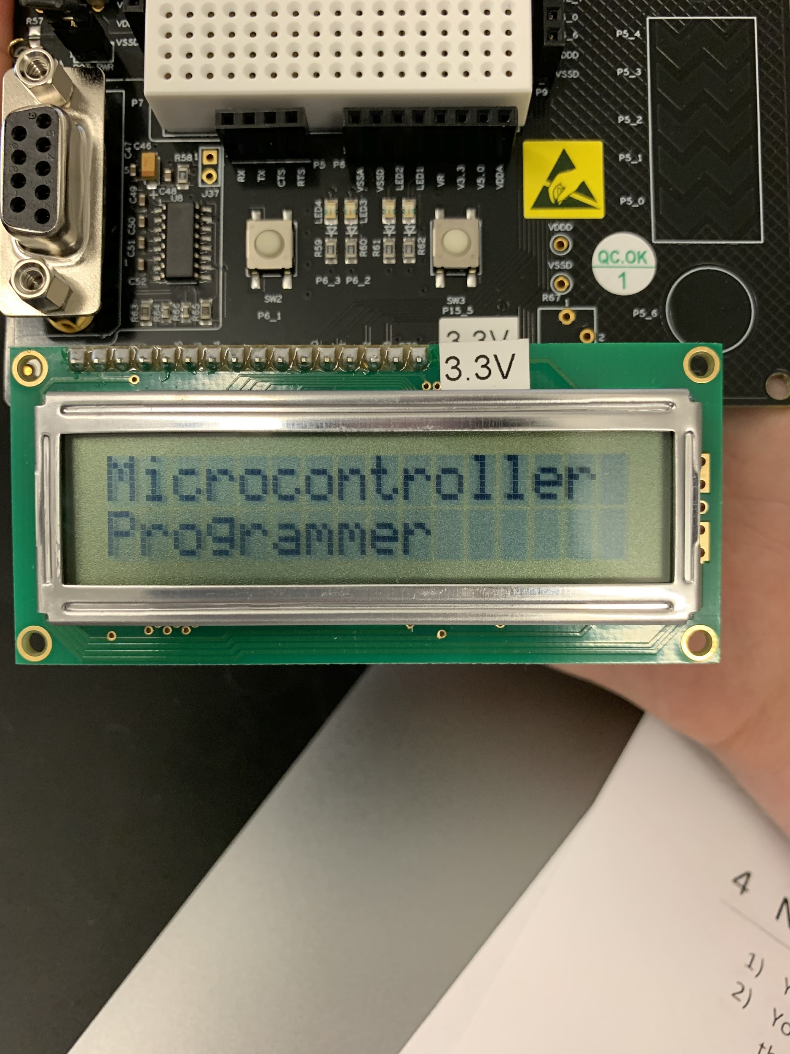

*Figure 3. Third Line Displayed of Part 1*

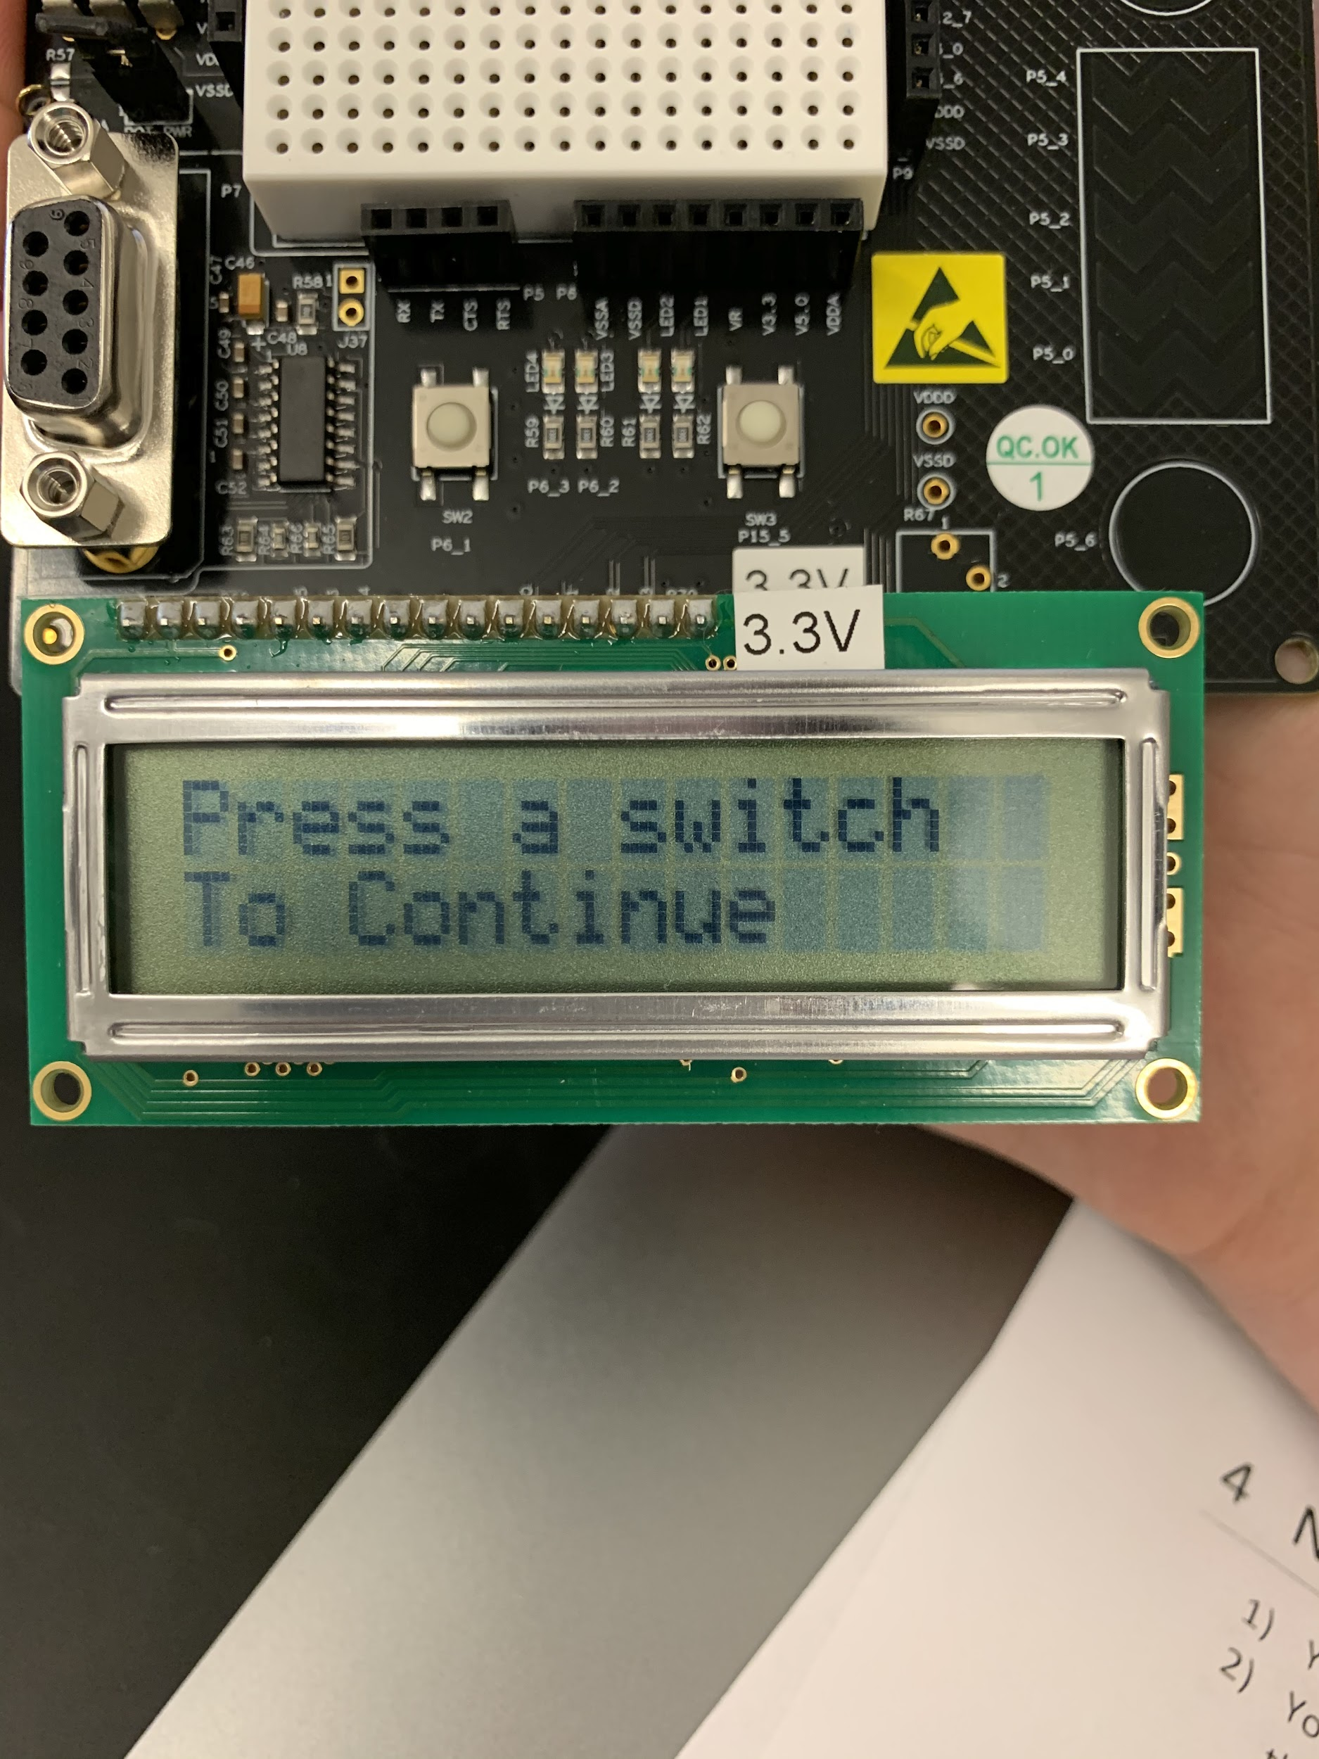

*Figure 3. Fourth Line Displayed of Part 1*

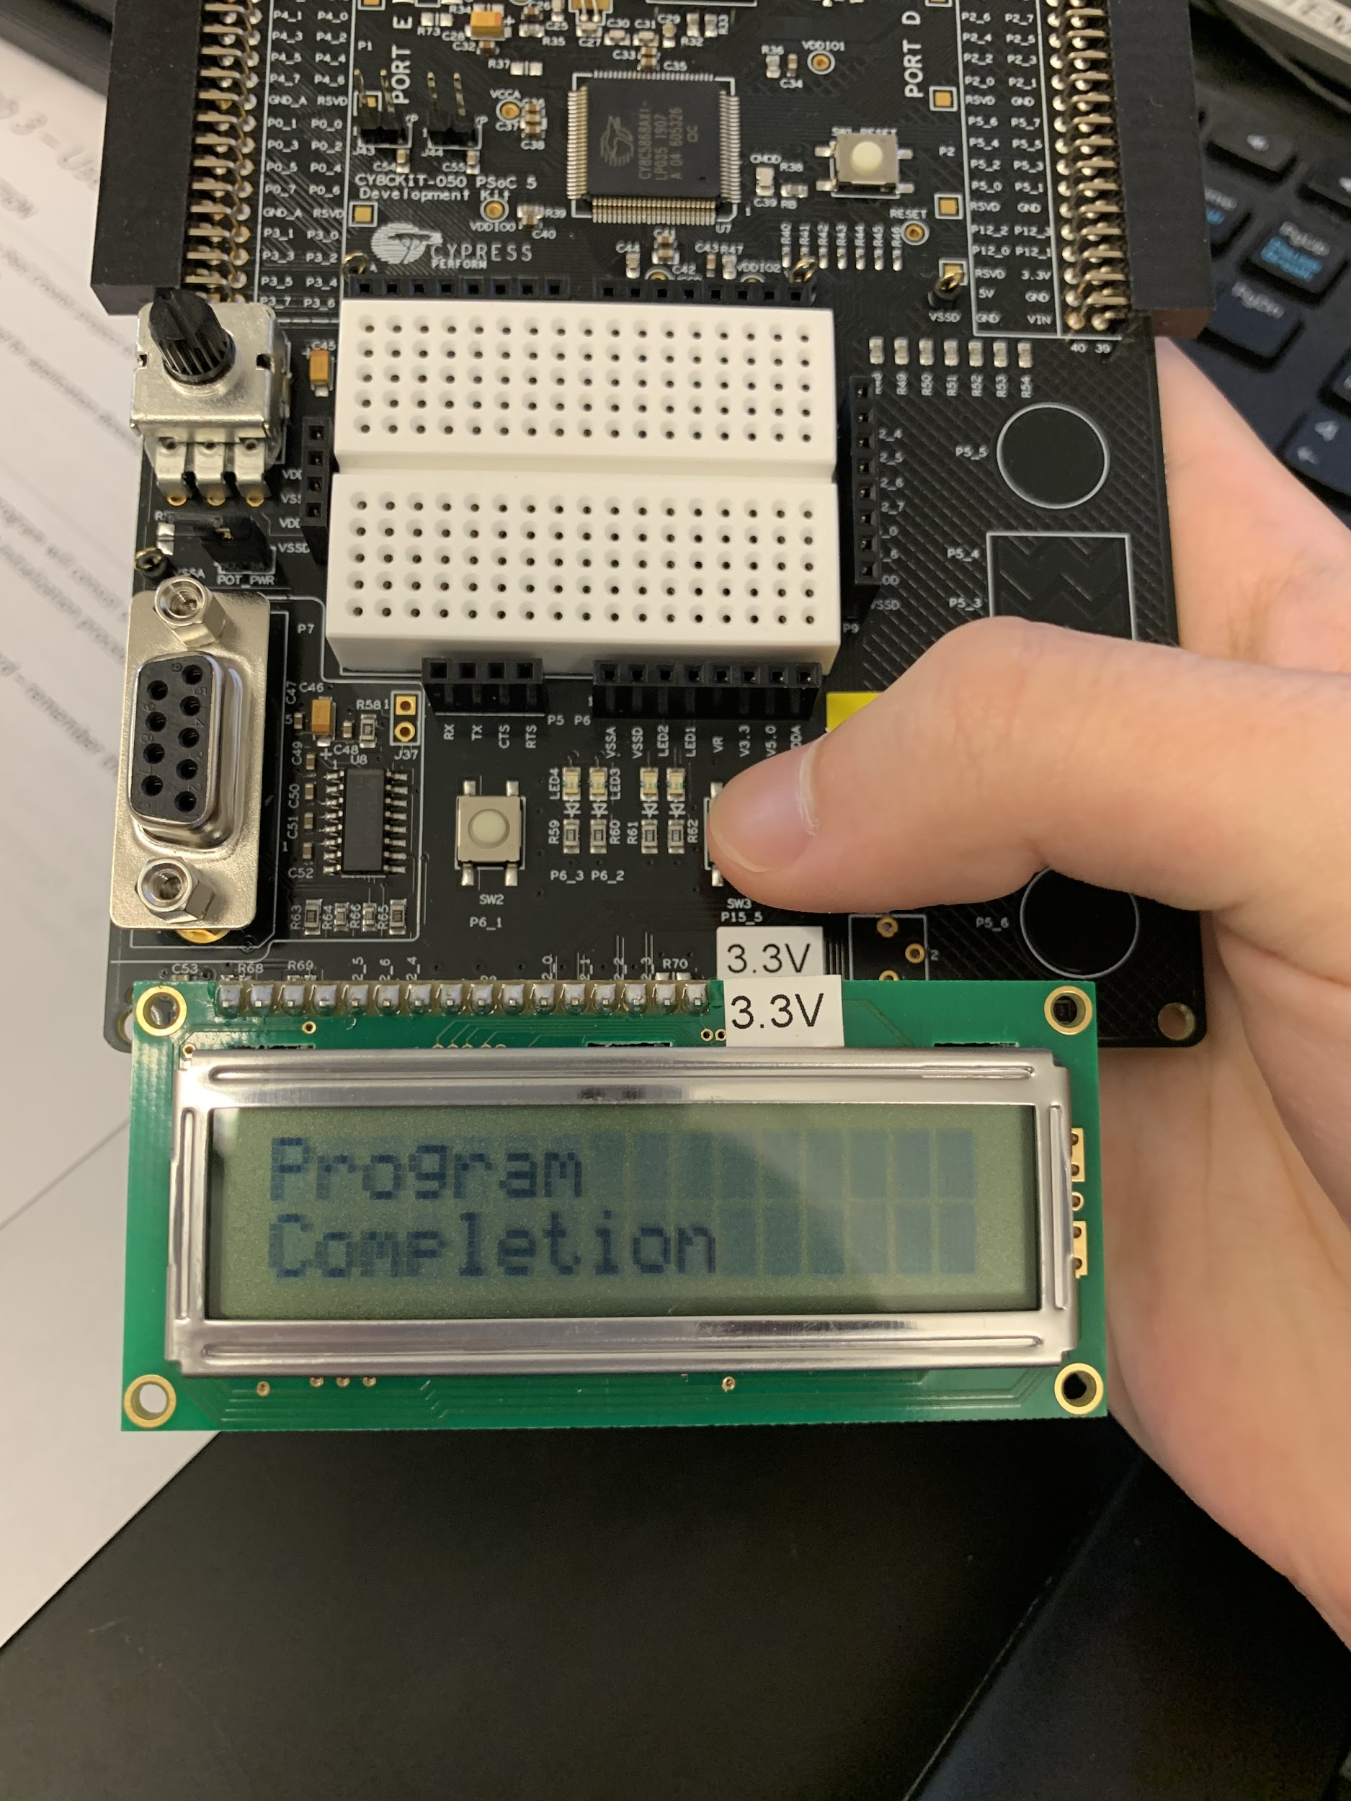

*Figure 5. Line Displayed After Switch is Pressed*

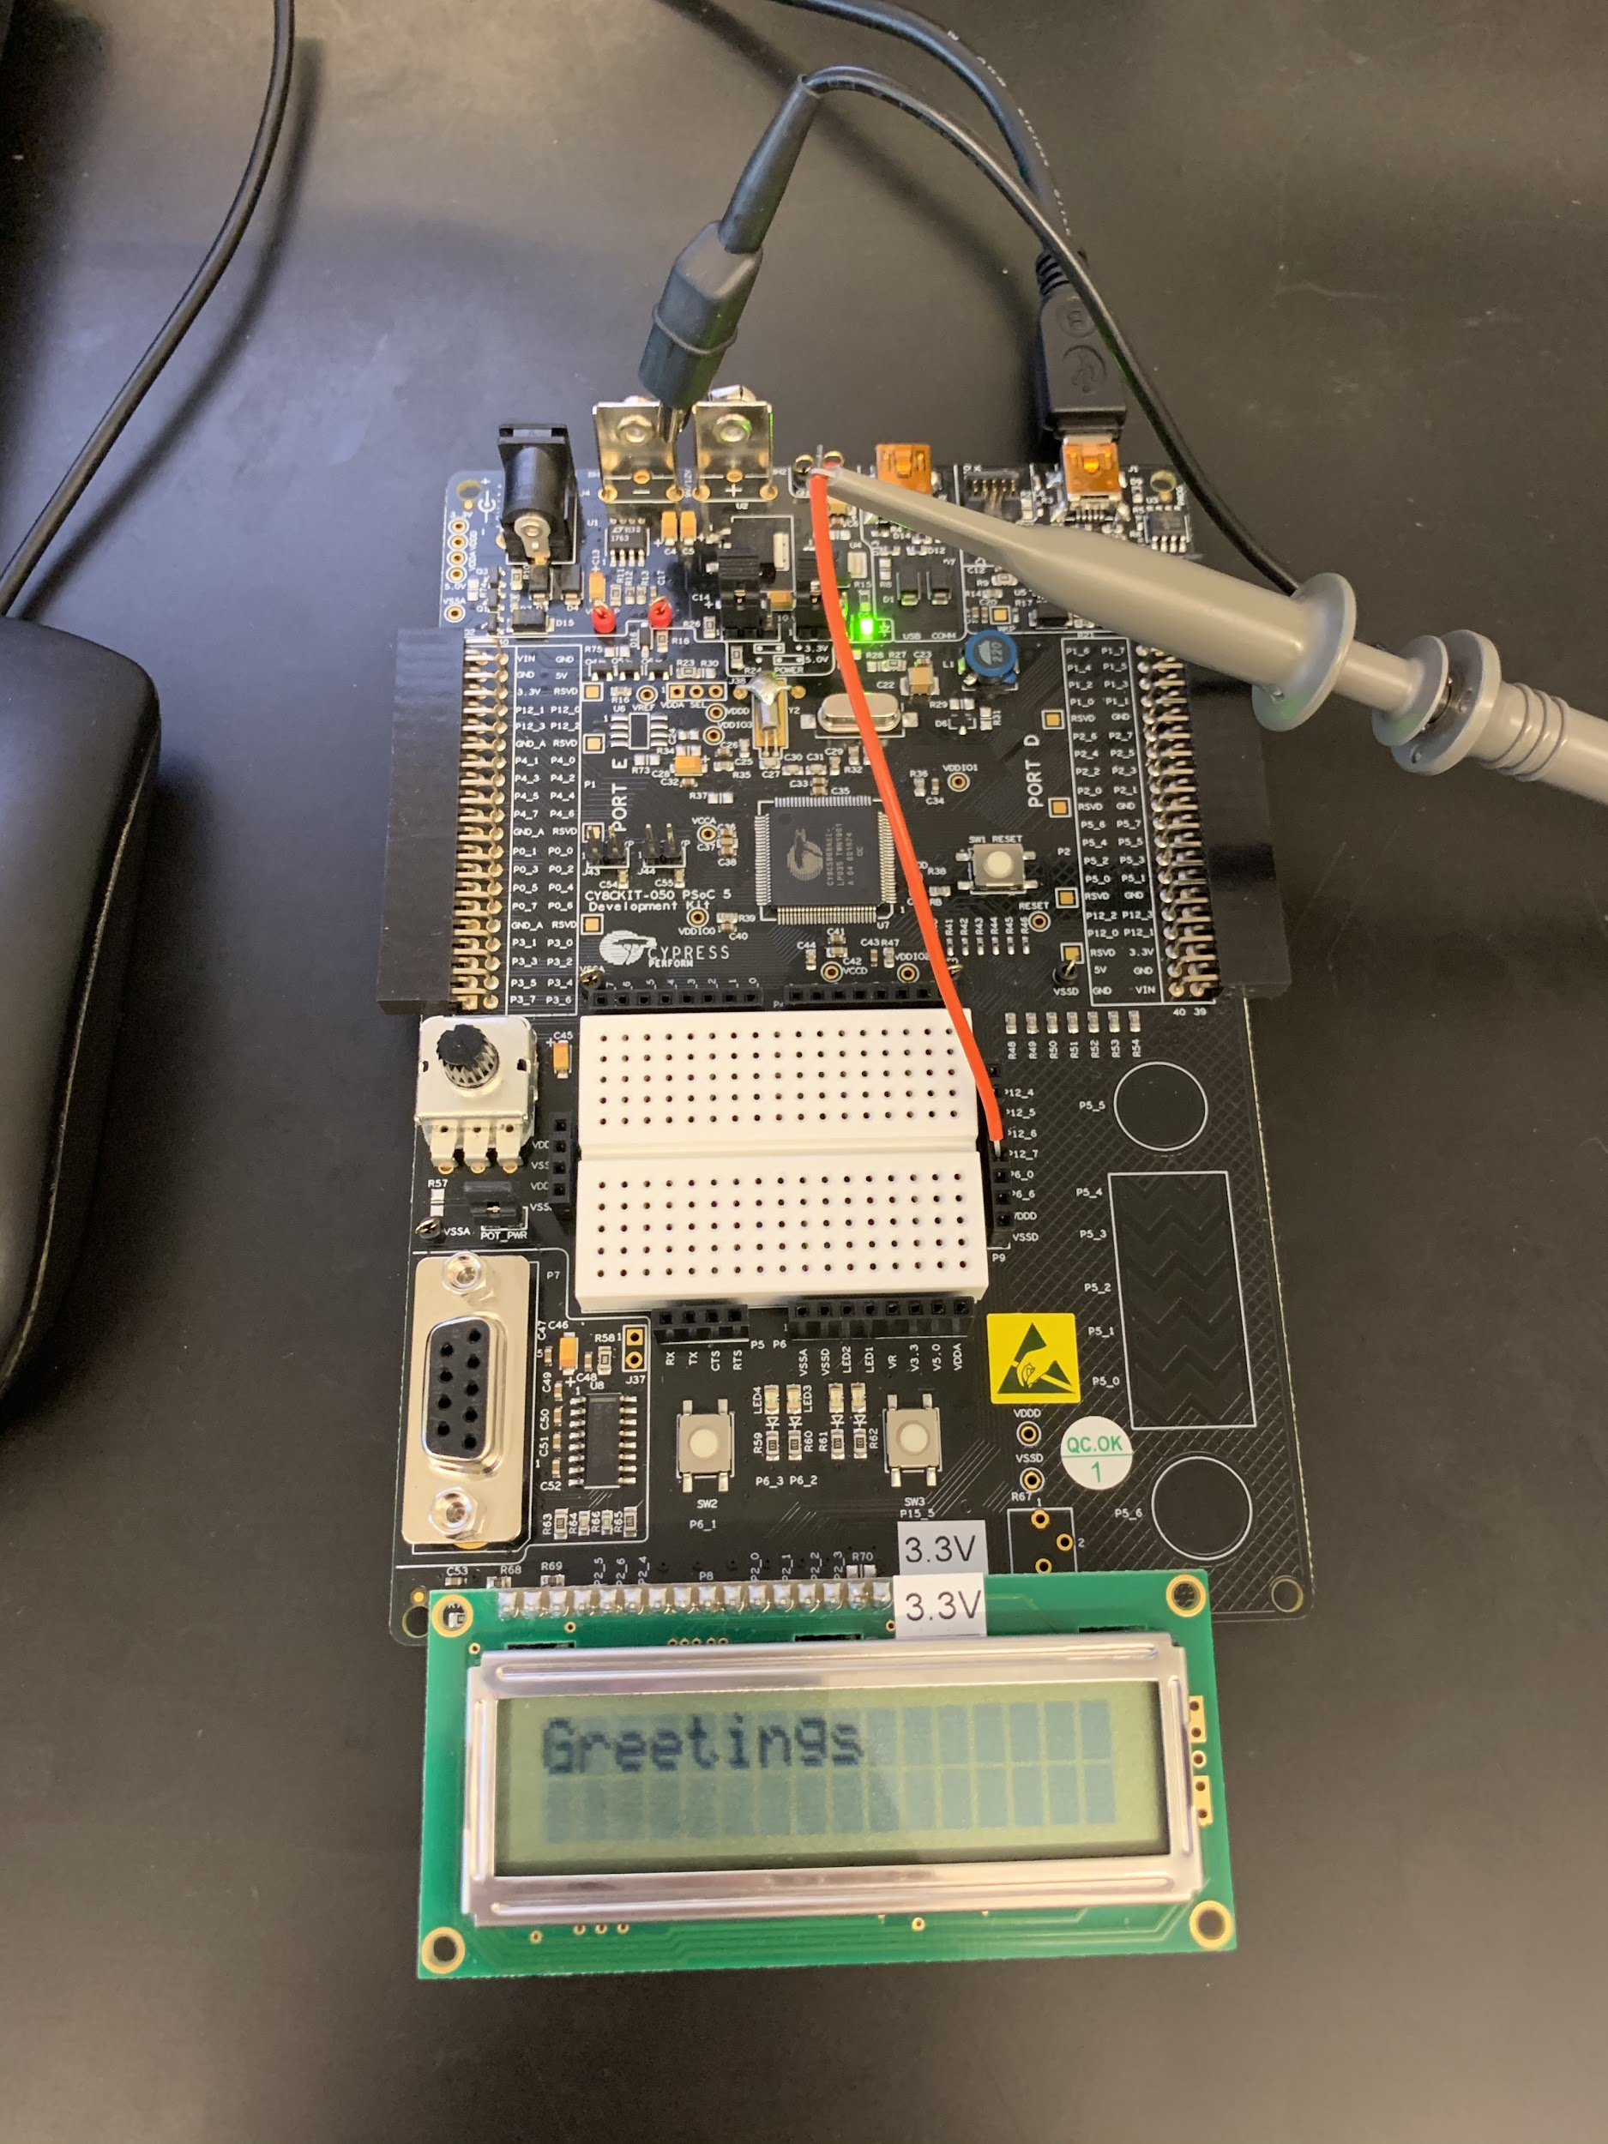

*Figure 6. First Line Displayed of Part 2*

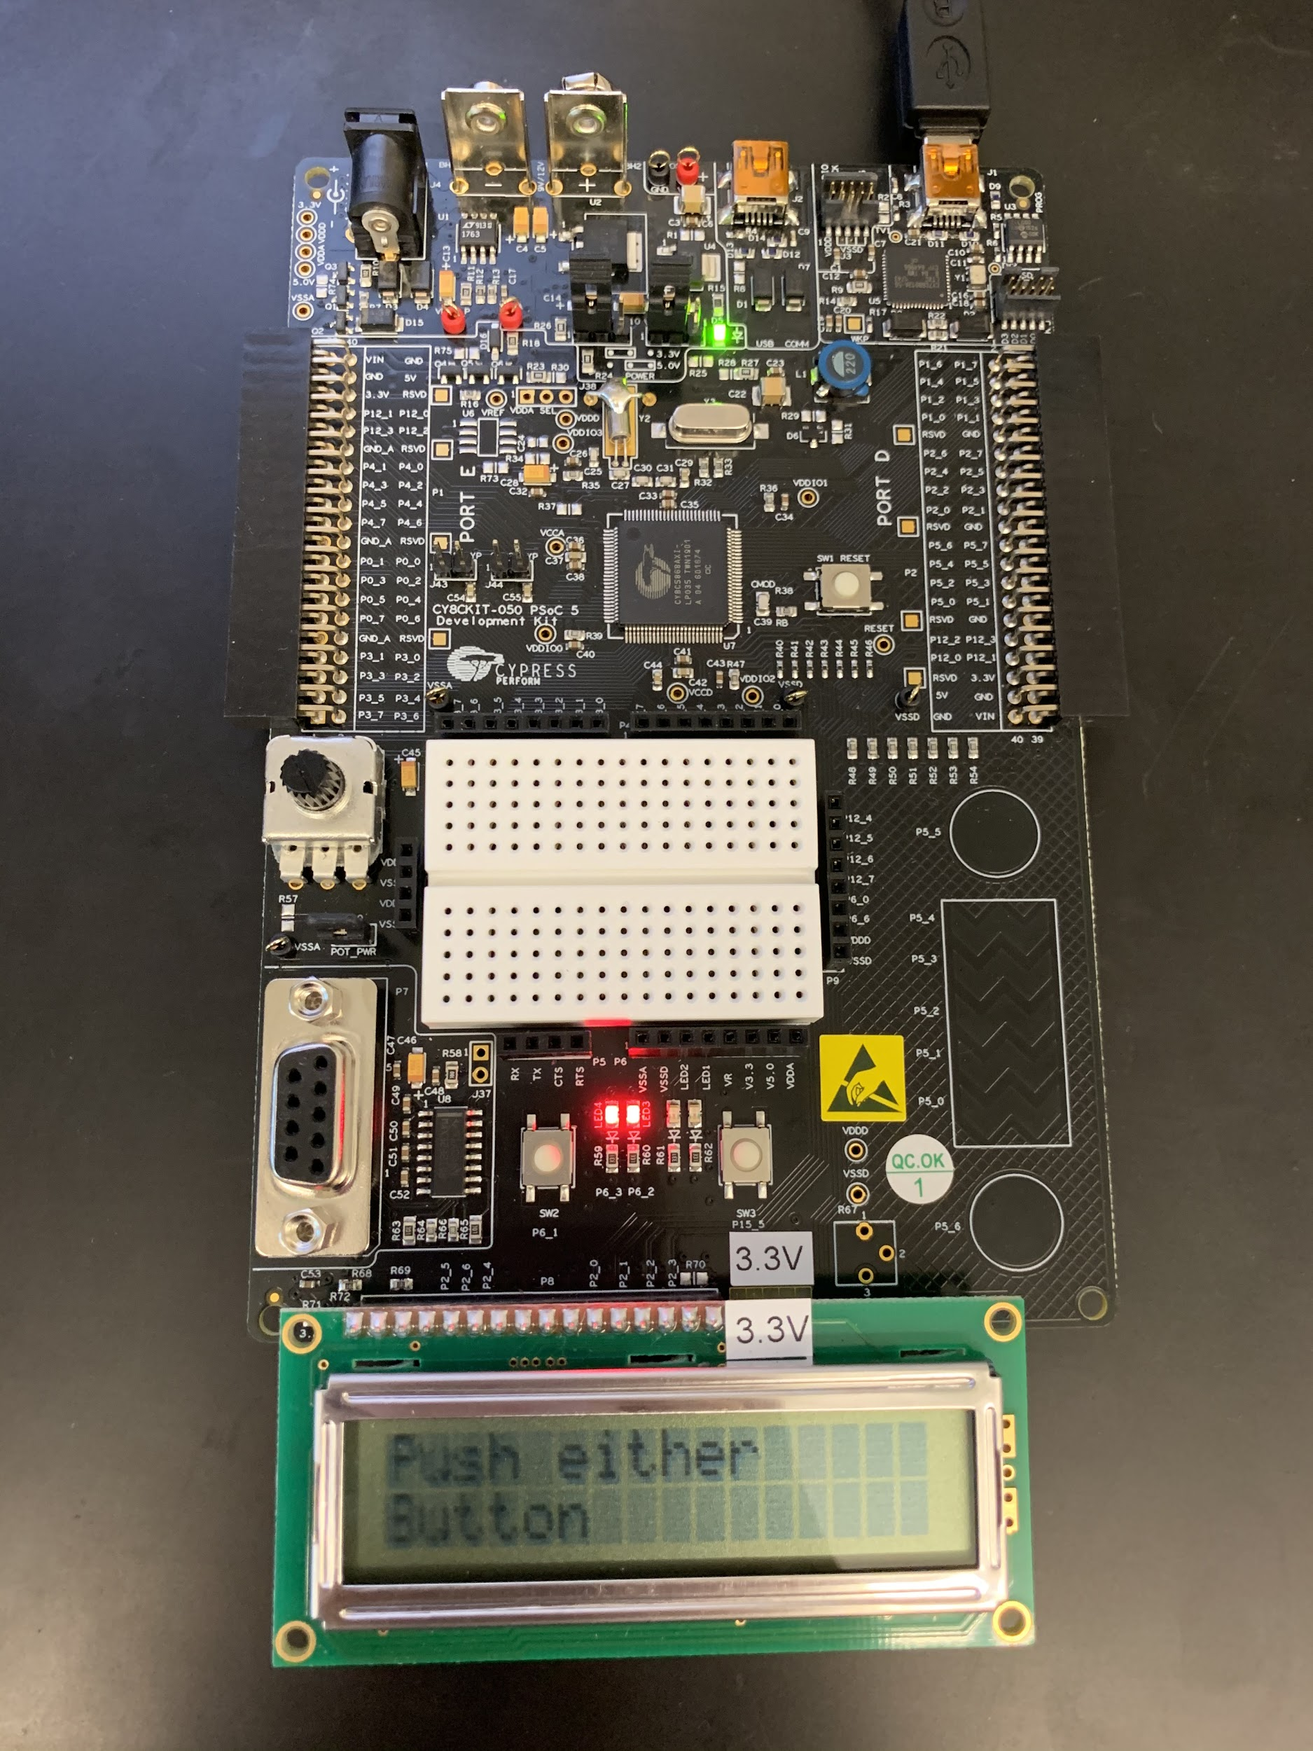

*Figure 7. Second Line Displayed of Part 1 With Both LEDs On*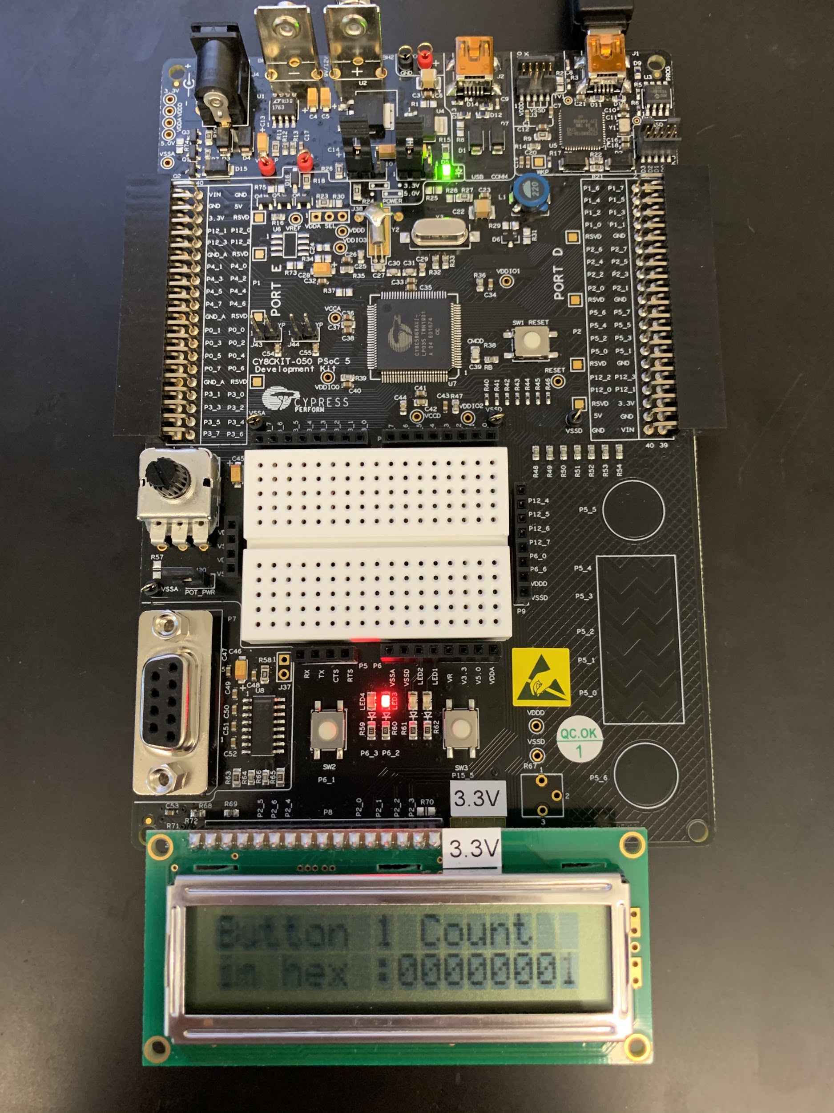

*Figure 8. Line Displayed After Button 1 is Pressed and First LED Toggled*

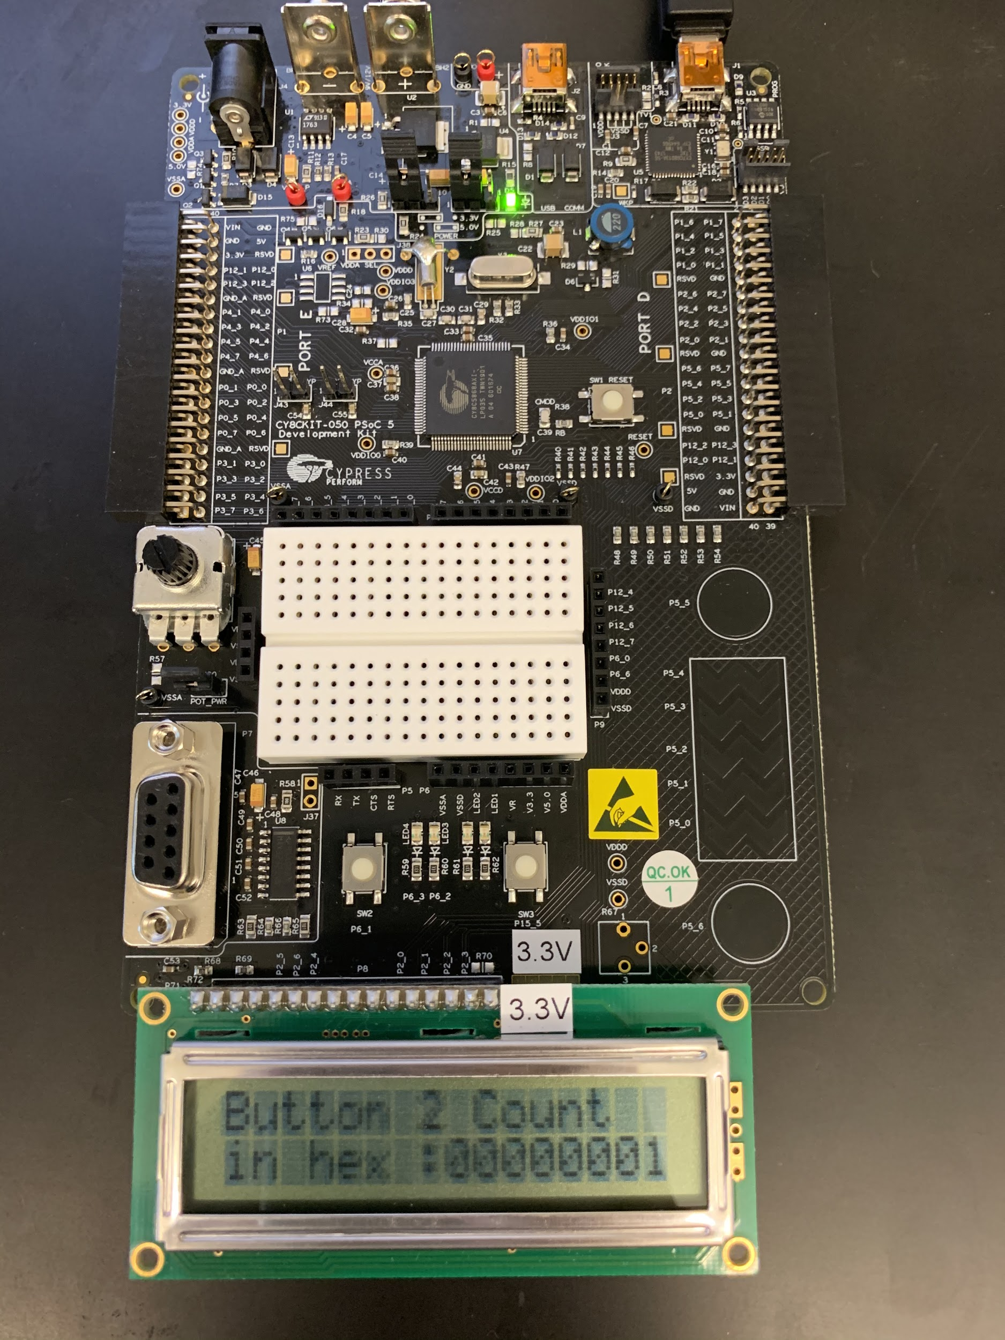

*Figure 9. Line Displayed After Button 2 is Pressed and Second LED Toggled*

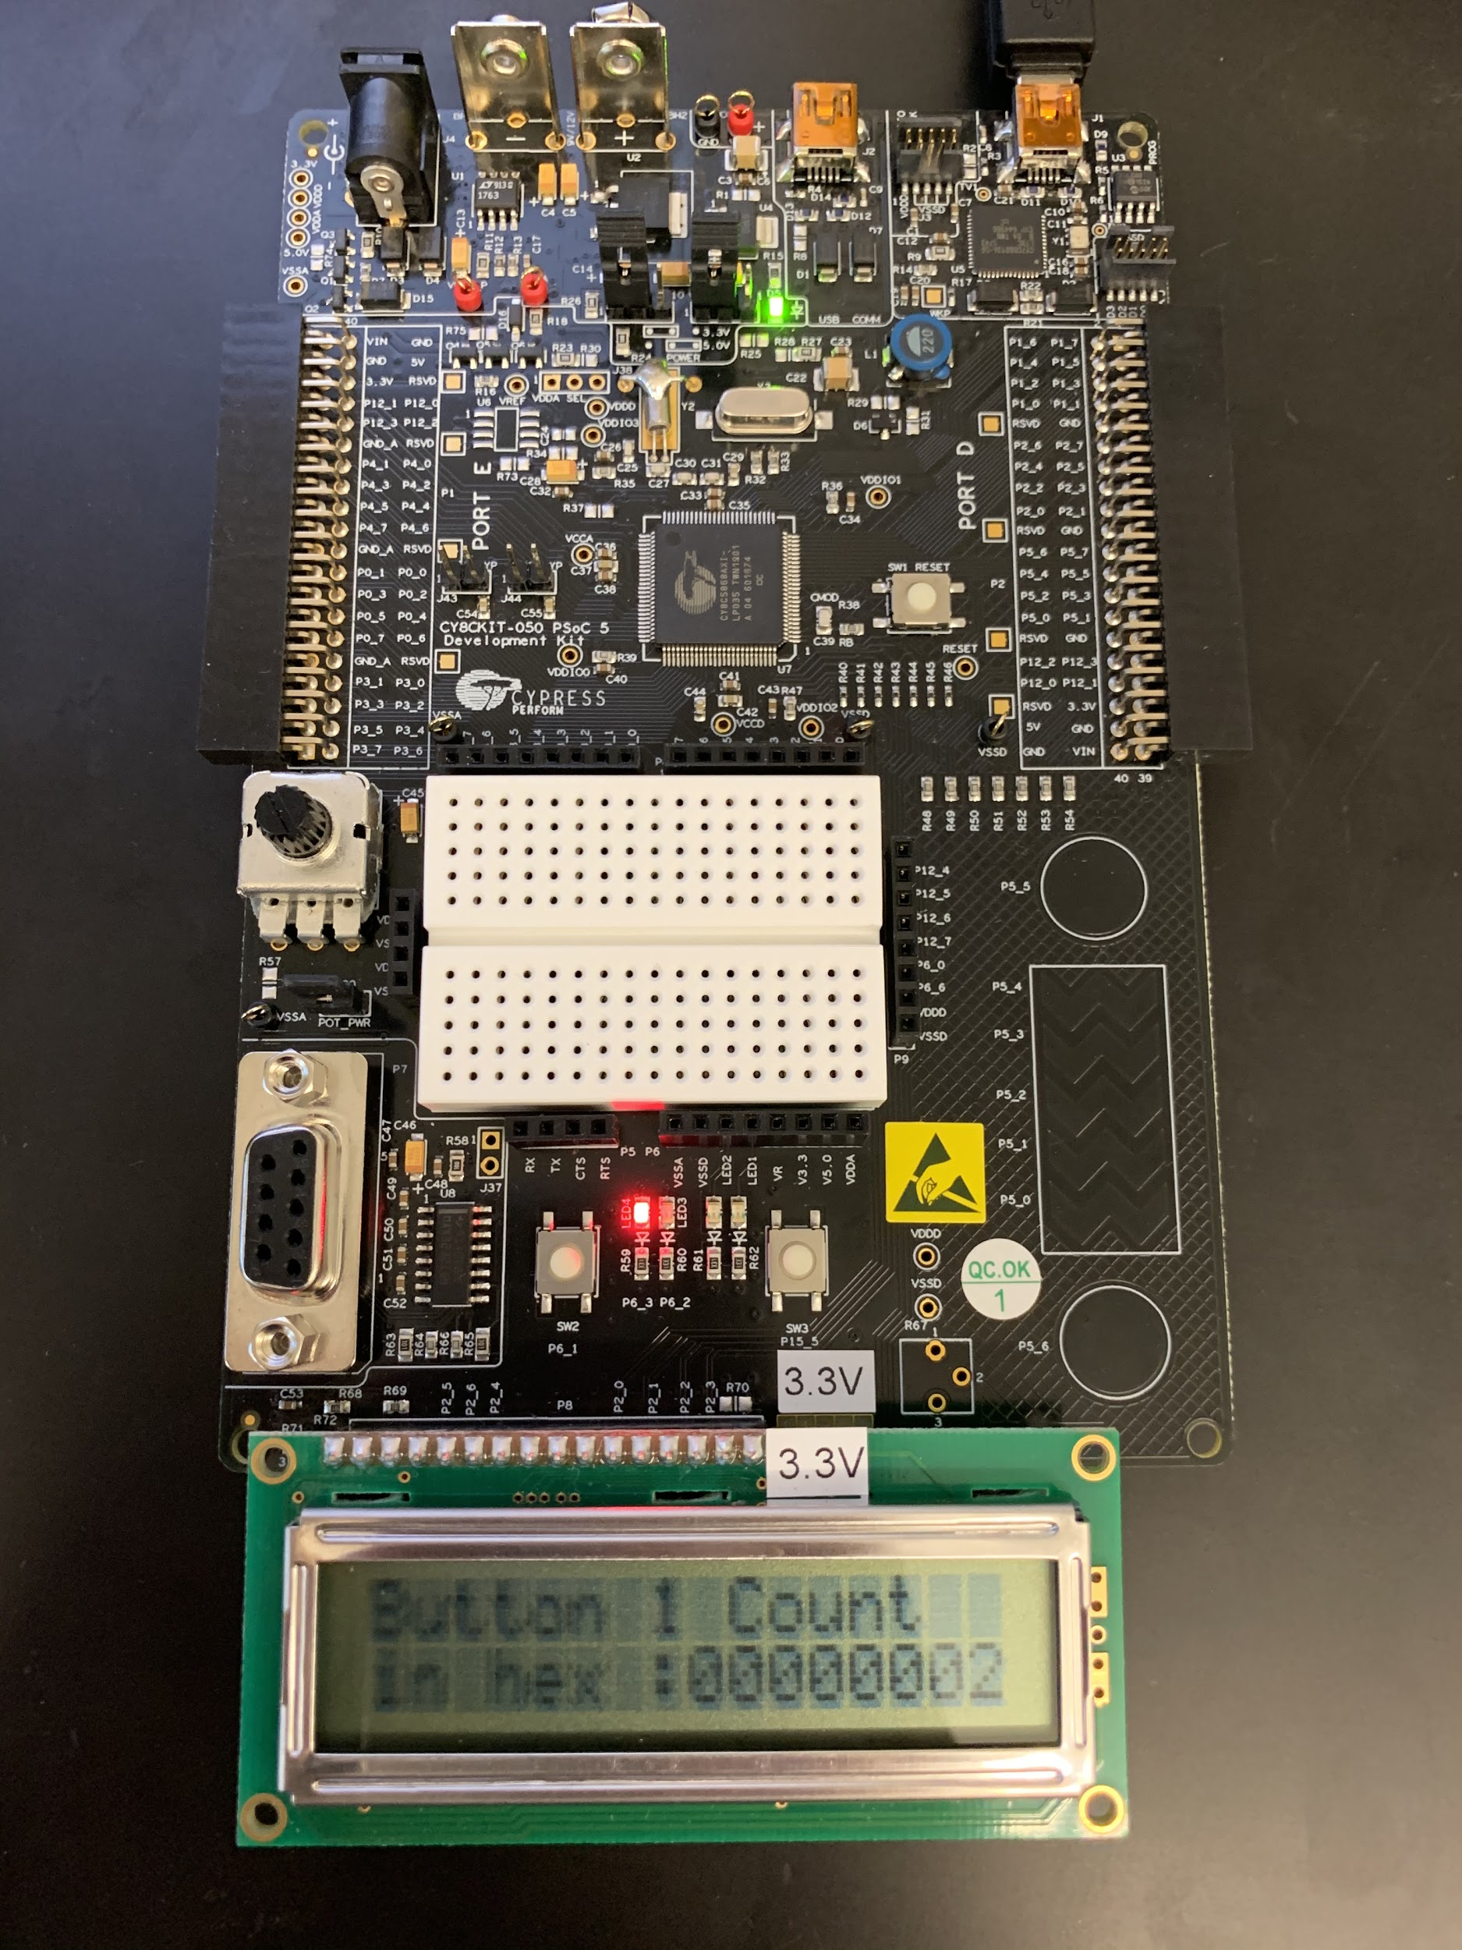

*Figure 10. Line Displayed After Button 1 is Pressed Again and First LED Toggled*

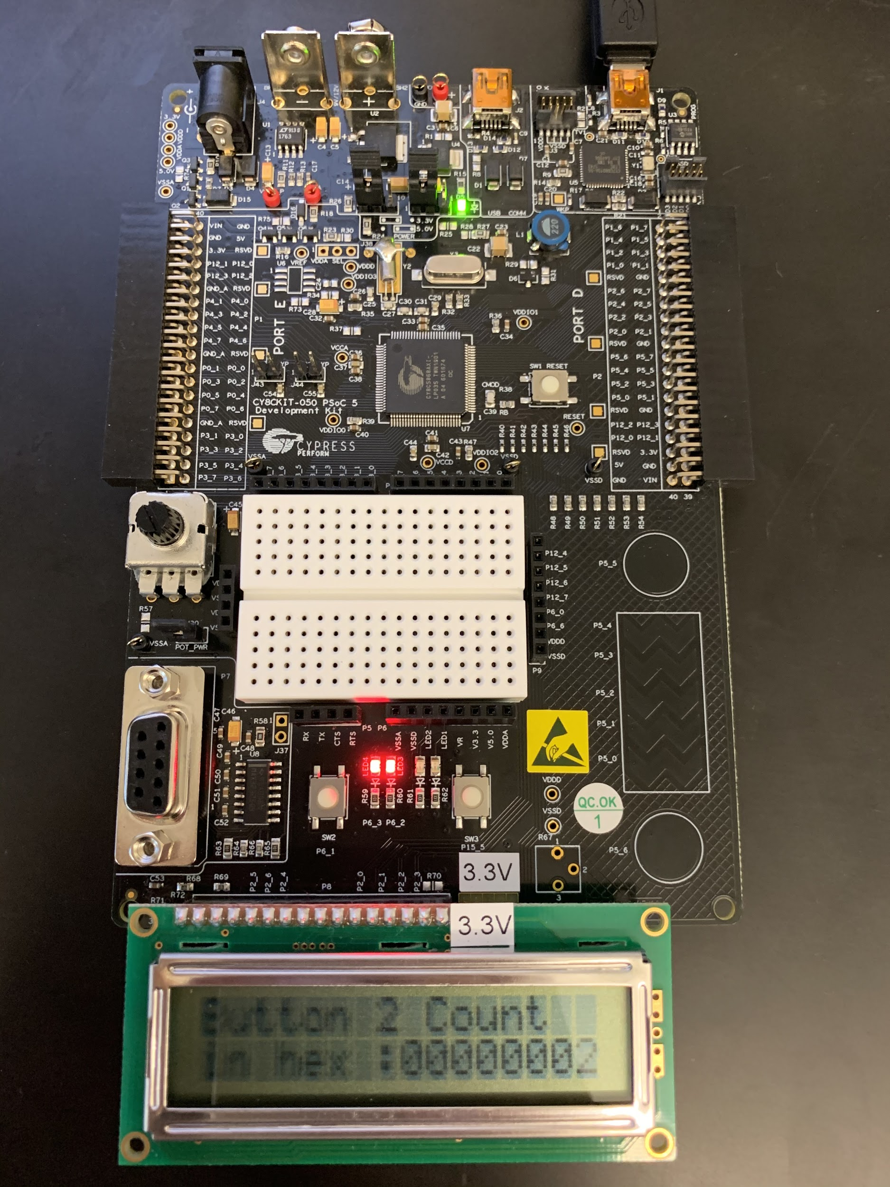

*Figure 11. Line Displayed After Button 2 is Pressed Again and First LED Toggled*

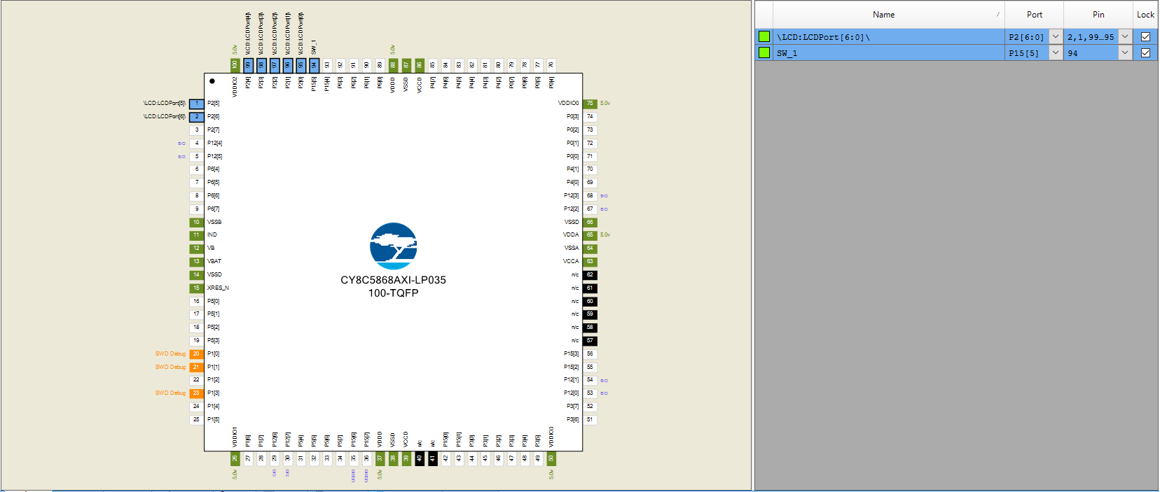

*Figure 12. Schematic for Greeting Message in Part 1*

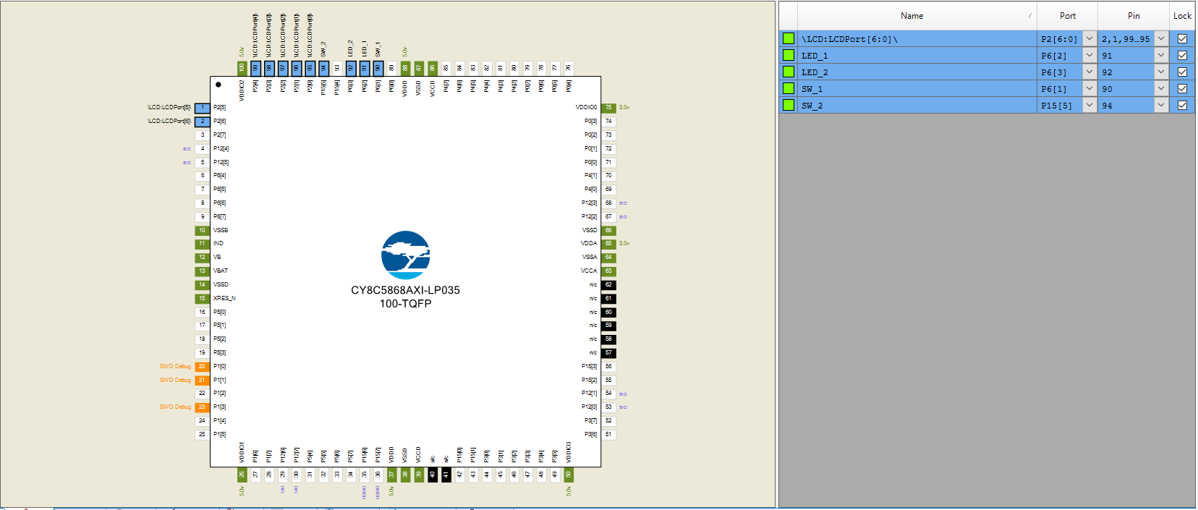

*Figure 13. Schematic for Hex Counter in Part 2*

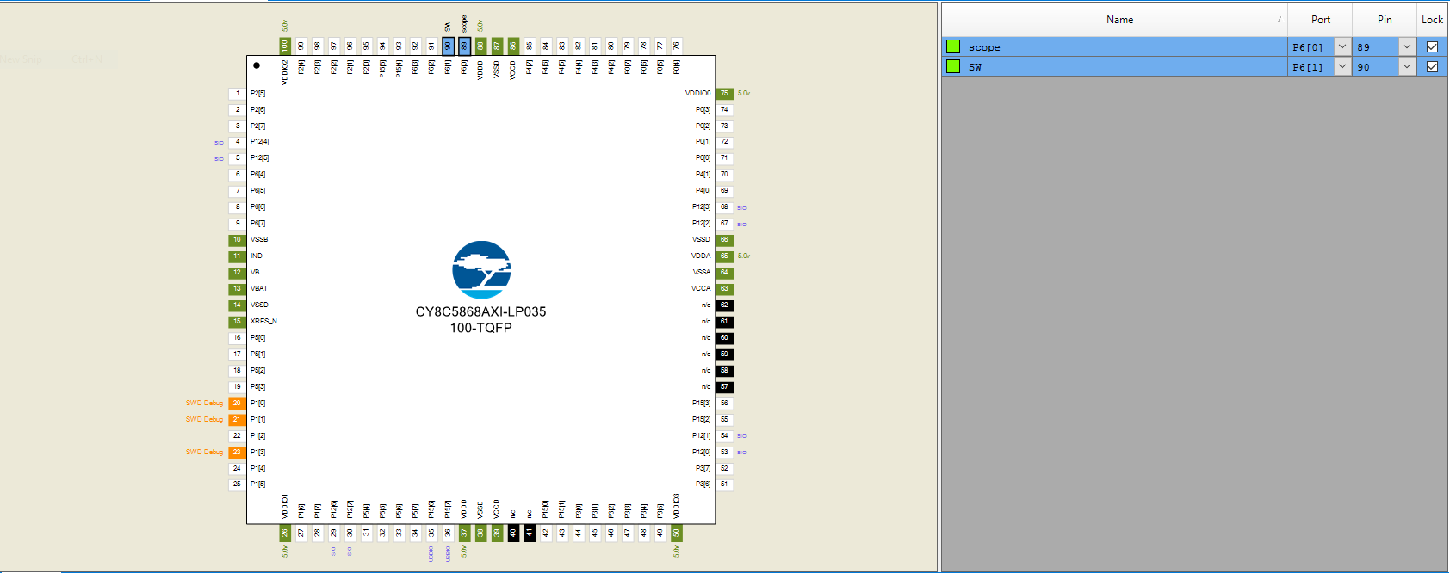

*Figure 14. Schematic for Debugging Debouncing*

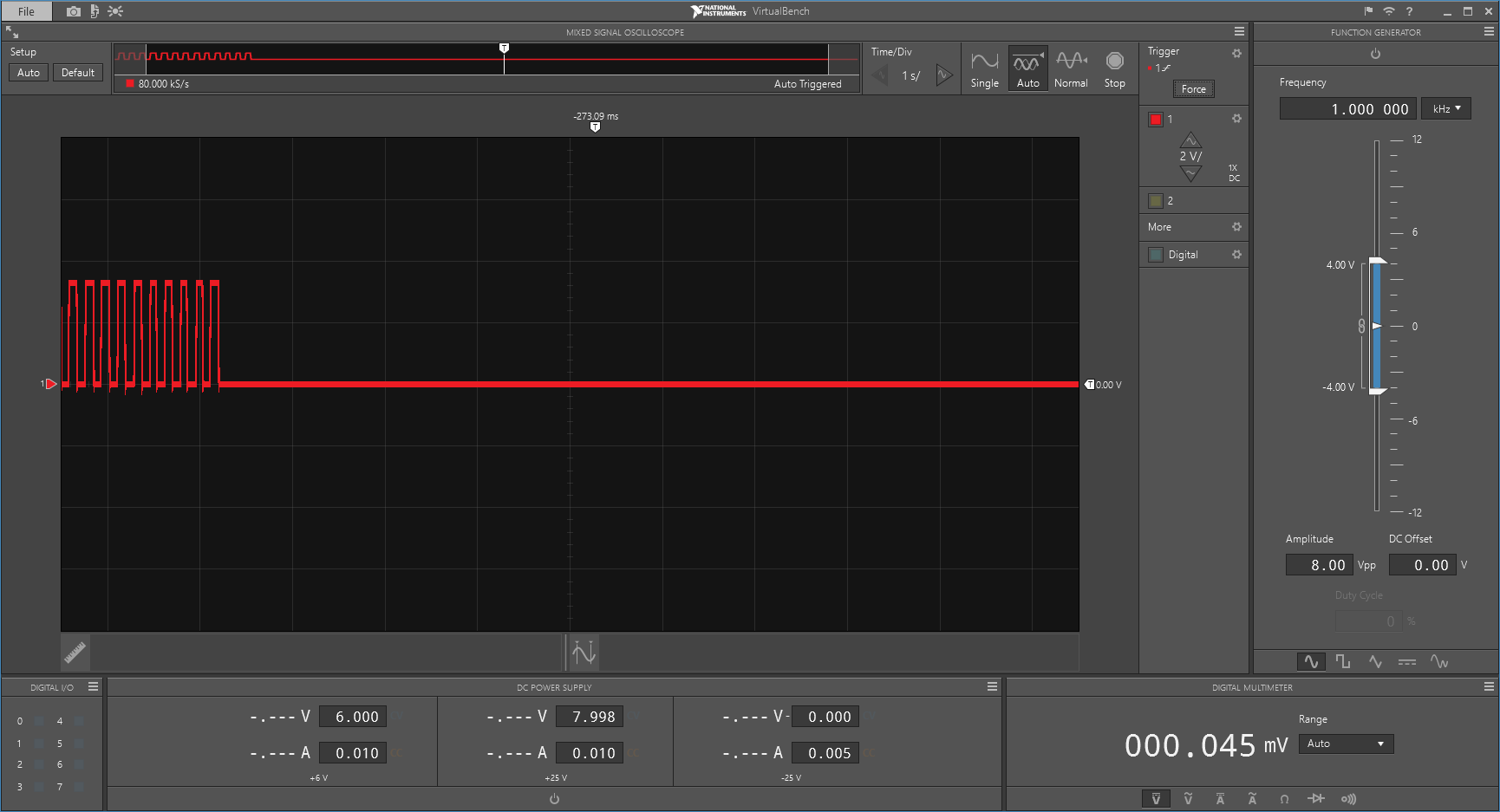

*Figure 15. Oscilloscope Reading Displaying the Debouncing Effect*

|  |  |
| --- | --- |
| Time/Division | 1 |
| Volts/Division | 2V |

*Table 1. Values of Oscilloscope reading*

else if (SW_2_Read() ==0)

{

count2 = count2 + 1;

char count[4096]="";

sprintf(count,"in hex :%08x",count2);

LCD_ClearDisplay();

LCD_Position(0,0);

LCD_PrintString("Button 2 Count");

LCD_Position(1,0);

LCD_PrintString(count);

LED_1_Write(!LED_1_Read());

CyDelay(100);

while(SW_2_Read()==0)

{

}

*Figure 16: Code Snippet displaying delay introduced to stop switch bouncing*

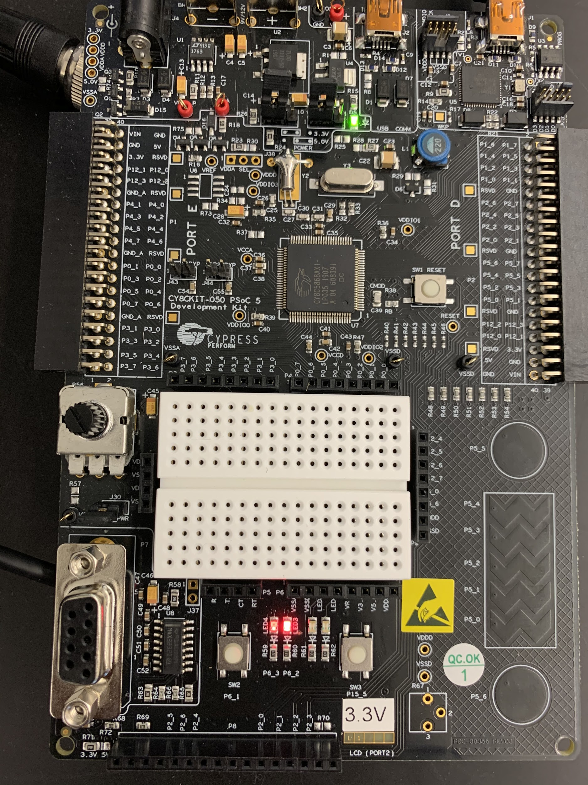

*Figure 17: LED 1 at Lowest Intensity; LED 2 at Highest Intensity*

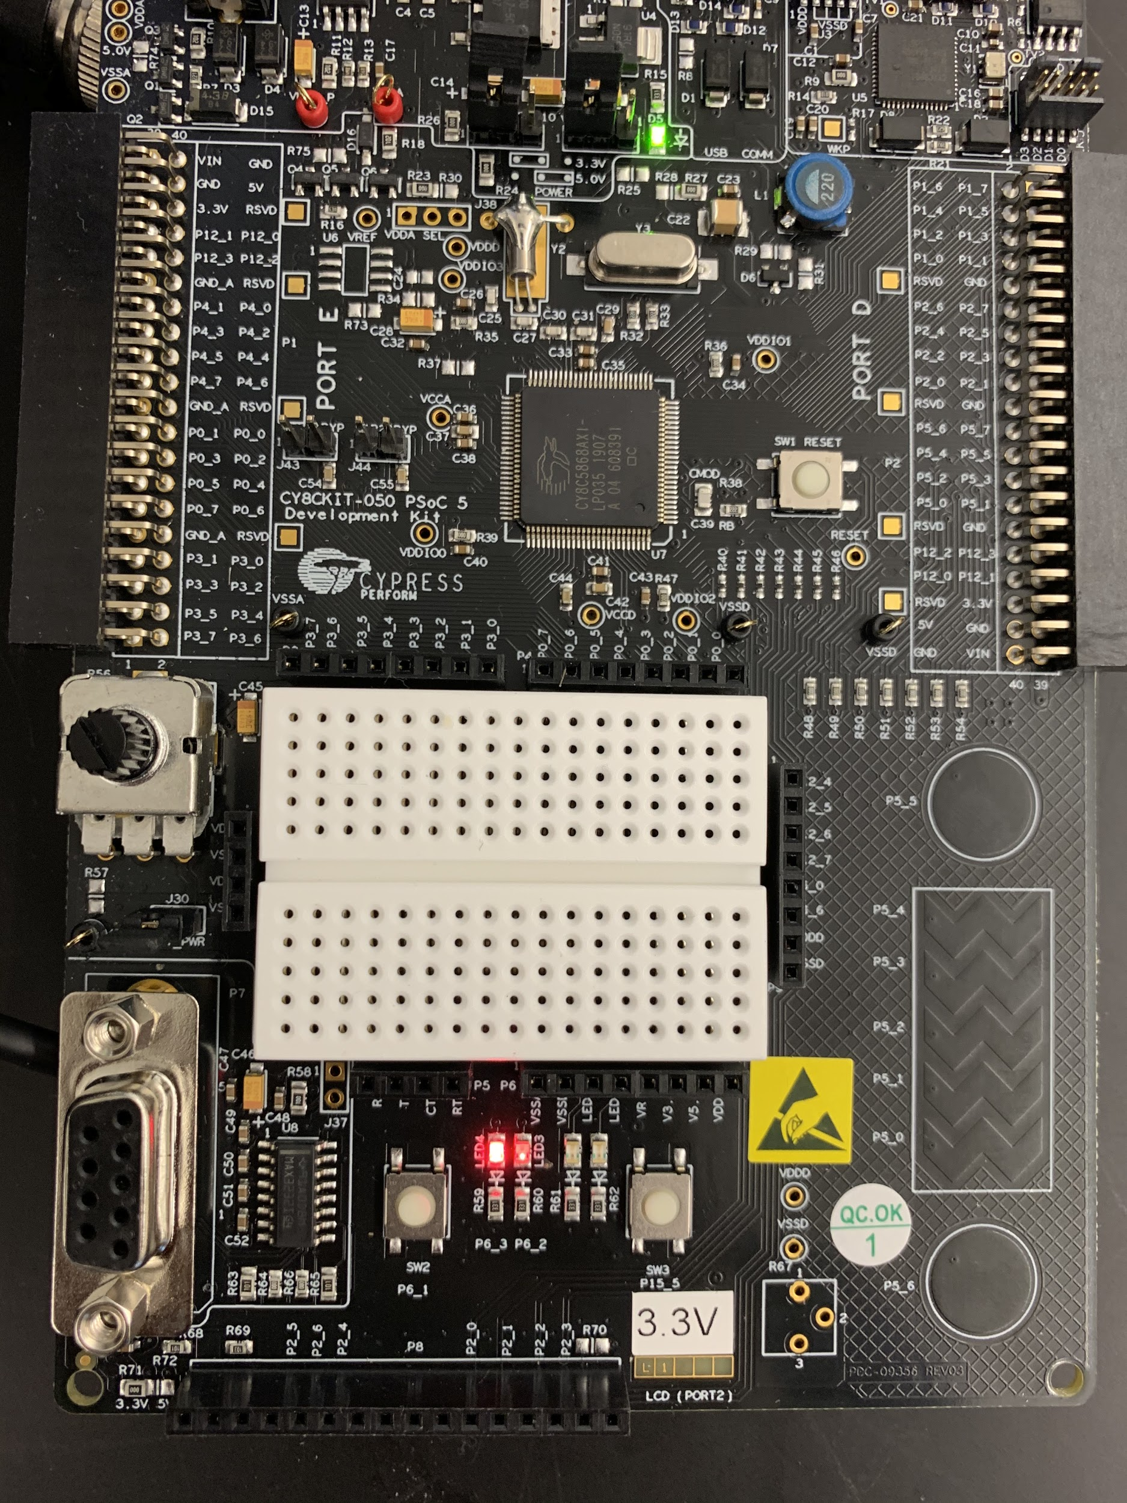

*Figure 18: LED 2 at Lowest Intensity; LED 1 at Highest Intensity*

**Discussion:**

The students when driving the LCD opted for a refreshing method where the message would be displayed and then the whole display would be refreshed for the next method. This was chosen as a line by line method proved to be visually unappealing. The button debounce issue was the main problem the students had to overcome. Switch bouncing occurs because when a button is pressed as there is not just one singular contact. Instead the two contacts separate and reconnect many times in a very short period of time, usually a few milliseconds. This fluctuation of states causes a problem unless a delay is introduced. As this occurs both when the button is pushed down and when it comes back up, the students had to introduce a delay that would account for both the push down and the button coming back up. This resulted in there being a delay in the code every time a button was pressed. When the students were driving both LED’s in the opposite directions in terms of brightness, they achieved this by setting the CMP type for the first LED to less than and greater than for the second LED.

**Conclusion:**

All parts of the lab worked as expected. The first part showed the correct messages and then updated correctly. The second part took in user input via the push buttons and then displayed the correct information to the LCD. This part also accounted for the switch bouncing. The students found the switch bouncing to be an interesting phenomenon and didn’t expect it. The third part showed the LED’s increasing and decreasing in brightness correctly and showed that when one LED was at the highest brightness the other one was at the lowest brightness.

**Code:**

Part 1 Code:

#include "project.h"

int main(void)

{

CyGlobalIntEnable; /* Enable global interrupts. */

/* Place your initialization/startup code here (e.g. MyInst_Start()) */

LCD_Start();

LCD_Position(0,0);

LCD_PrintString("My First");

LCD_Position(1,0);

LCD_PrintString("Microcontroller");

CyDelay(2000);

LCD_ClearDisplay();

LCD_Position(0,0);

LCD_PrintString("I/O Console");

LCD_Position(1,0);

LCD_PrintString("Program");

CyDelay(2000);

LCD_ClearDisplay();

LCD_Position(0,0);

LCD_PrintString("Microcontroller");

LCD_Position(1,0);

LCD_PrintString("Programmer");

CyDelay(2000);

LCD_ClearDisplay();

LCD_Position(0,0);

LCD_PrintString("Press a switch");

LCD_Position(1,0);

LCD_PrintString("To Continue");

for(;;)

{

if(SW_1_Read()==0)

{

LCD_ClearDisplay();

LCD_Position(0,0);

LCD_PrintString("Program");

LCD_Position(1,0);

LCD_PrintString("Completion");

CyDelay(2000);

LCD_ClearDisplay();

LCD_Position(0,0);

LCD_PrintString("Completion");

LCD_Position(1,0);

LCD_PrintString("Succeeded");

}

}

}

Part 2 Code:

#include "project.h"

#include <string.h>

int main(void)

{

CyGlobalIntEnable; /* Enable global interrupts. */

/* Place your initialization/startup code here (e.g. MyInst_Start()) */

LED_1_Write(1);

LED_2_Write(1);

LCD_Start();

LCD_Position(0,0);

LCD_PrintString("Greetings");

CyDelay(2000);

LCD_ClearDisplay();

LCD_PrintString("Push either");

LCD_Position(1,0);

LCD_PrintString("Button");

int count1 = 0,count2 = 0;

for(;;)

{

if(SW_1_Read()==0)

{

count1 = count1 + 1;

char count[4096]="";

sprintf(count,"in hex :%08x",count1);

LCD_ClearDisplay();

LCD_Position(0,0);

LCD_PrintString("Button 1 Count");

LCD_Position(1,0);

LCD_PrintString(count);

LED_2_Write(!LED_2_Read());

CyDelay(100);

while(SW_1_Read()==0)

{

}

}

else if (SW_2_Read() ==0)

{

count2 = count2 + 1;

char count[4096]="";

sprintf(count,"in hex :%08x",count2);

LCD_ClearDisplay();

LCD_Position(0,0);

LCD_PrintString("Button 2 Count");

LCD_Position(1,0);

LCD_PrintString(count);

LED_1_Write(!LED_1_Read());

CyDelay(100);

while(SW_2_Read()==0)

{

}

}

}

}

Debugging Code:

#include "project.h"

int main(void)

{

CyGlobalIntEnable; /* Enable global interrupts. */

/* Place your initialization/startup code here (e.g. MyInst_Start()) */

for(;;)

{

if(SW_Read()==0)

{

scope_Write(1);

CyDelay(100);

}else{

scope_Write(0);

CyDelay(100);

}

}

}

Part 4:

#include "project.h"

int main(void)

{

CyGlobalIntEnable; /* Enable global interrupts. */

PWM_1_Start();

Clock_1_Start();

for(;;)

{

for( int i = 1; i < 255; i++){

PWM_1_WriteCompare1(i);

PWM_1_WriteCompare2(i);

CyDelay(10);

}

for( int i = 255; i > 0; i--){

PWM_1_WriteCompare1(i);

PWM_1_WriteCompare2(i);

CyDelay(10);

}

}

}